
Southern Melbourne Child & Family Alliance

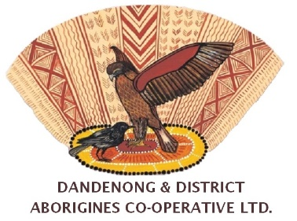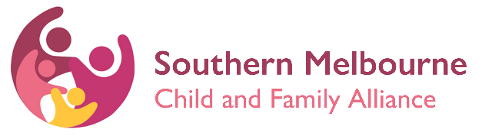

First Nations Consultation
Aboriginal Liaison Worker

The Aboriginal Liaison Worker (ALW) is employed by DDACL to provide cultural advice and casework support to Family Services in the Southern Melbourne catchment area.

The ALW role supports the provision of a culturally appropriate response to First Nations families via identified consults with Family Services Practitioners (where the family consents to consultation with DDACL) or via deidentified cultural consults (where the family has not consented to consultation with DDACL).

The ALW may:
- Provide cultural advice to Family Services practitioners for all Aboriginal and Torres Strait Islander families referred into mainstream SMCFA agencies.
- Where appropriate, support the practitioner to engage the family by attending joint visits to the family home and providing ongoing support through the life of the case as required.
- Assist the practitioner to identify and link families to culturally appropriate services for Aboriginal and Torres Strait Islander families.
- Support the practitioner to understand and reflect on the family’s history of trauma.
- Provide information, advice and support in relation to Aboriginal and Torres Strait Islander parenting and family dynamics.

Secondary Consult Process
- Prior to meeting consultation the IFS practitioner to establish that the family identifies as Aboriginal and/or Torres Strait Islander.
- Seek the family’s consent for a consult to occur.
If no, would the family be comfortable with a deidentified consultation?

How can I access a consultation or support?
Dandenong & District Aborigines Co-operative Limited
- Contact: Holly Kennedy
- Email: Holly.kennedy@ddacl.org.au
- Phone: 0461 449 935

