
Southern Melbourne Child & Family Alliance



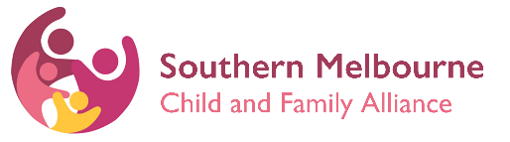

Adolescent Family Services Consulting Service

Available to discuss and support case practice with all thing’s adolescence. Alex Hacking, who is in this role, bring almost 10 years’ experience working directly with young people and their families.

Some examples for consults:
- Adolescent development
- Changing rules and boundaries
- Neurodivergence considerations and practice
- LGBTIQA+ best practice
- Adolescent/parent conflict
- Mediation ideas and how to
- Practice and engagement tools
- Safety plans
And more

How can I access a consultation or support?

- Please email afsconsulting@vt.uniting.org

Alex may send a request from to gather further details if needed. Alex is available to meet in-person, online and over the phone.

