What is student engagement – information sheet
Student engagement is challenging to define as it is a complex construct influenced by multiple factors.
Fredericks, Blumenfeld and Paris (2004) identify three dimensions of engagement:
- behavioural engagement: students’ participation in education, including the academic, social and extracurricular activities of the school
- emotional engagement: students’ emotional reactions in the classroom and in the school (a sense of belonging or connectedness to the school)
- cognitive engagement: students’ investment in their learning (motivation and self-regulation).
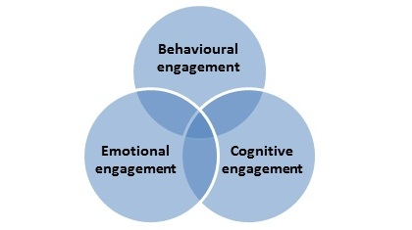

Factors that influence engagement
Some of the factors that influence student engagement at school are:
- Teacher factors: teacher interaction style (enjoyment and shared focus, support, responsiveness, directiveness, verbal praise), behavioural and academic expectations held
- School factors: includes physical setting factors (physical layout and arrangement of classroom, sensory factors/noise levels, lighting etc), and consistent and structured approaches to the provision of student support and disciplinary measures
- Student factors: a student’s physical, emotional, cognitive and behavioural state, including health issues and disability, peer relationships
- Family and community factors: a student's residential circumstances, family support for/involvement in education, and relationships with their family
- Curriculum and resources factors: availability and type of learning resources including technology, dimensions of the learning tasks (level of difficulty, interest, meaningfulness to learner), task design, learning goals and objectives, and assessment approaches.

Supporting the ‘whole’ student
The five dimensions of health and wellbeing represented below offer schools another, holistic way for schools to consider student engagement.
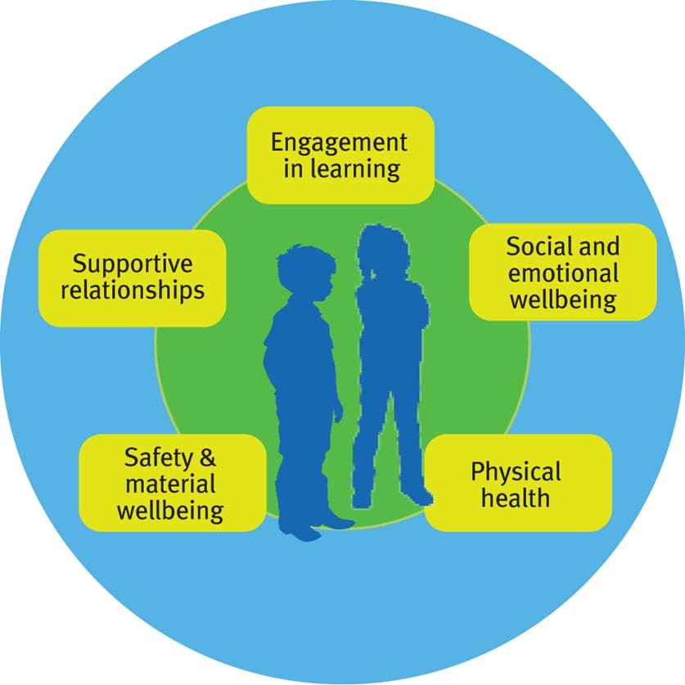
- Engagement in learning – includes active participation and engagement in learning, having functional skills to participate meaningfully in all aspects of one’s life; being competent as a learner and problem-solver; and having a sense of meaning.
- Social and emotional wellbeing – includes positive mental health / absence of mental health problems; self-awareness; emotional intelligence; self-regulation; resilience; interpreting the world positively; pro-social values and behaviour.
- Supportive relationships – includes having positive family bonds and friendship, ability to rely on a trusted adult, experiencing a sense of belonging, and engagement / involvement in age appropriate learning and activity.
- Physical health – includes physical health / absence of health problems; oral health; nutrition and weight; physical fitness; and self-management including sleeping.
- Safety and material wellbeing – includes sense of safety at home and school, being safe from injury and harm, having access to daily essentials and adequate and stable housing.
Adapted from The Australian Research Alliance for Children and Youth (ARACY) “Common Approach to Assessment, Referral and Support” wheel 2013 and Moore, T., McDonald, M., Tollit, M., & Bennett, K., “Children and young people’s health and wellbeing in educational settings: A review of the evidence” Murdoch Childrens Research Institute, 2013.

Further reading
Fredericks, J. A., Blumenfeld, P. C. & Paris, A. H. (2004). School engagement: potential of the concept, state of the evidence. Review of Educational Research, 74, 59-109.
McDonald, T. (2010). Classroom Management: Engaging Students in Learning. South Melbourne, VIC: Oxford University Press.
Parsons, J. & Taylor, L. (2011). Student Engagement: What do we know and what should we do? AISI University Partners, Edmonton: Alberta Education. ​​

