
SMCFA & SMFVRIC

Child and Family Working Group (0-10)

Morning Series Summary:

Building rapport with challenging clients

Thursday 3rd April 2025

Guest Speaker: Dr. Maxwell Fraser, Principal Practitioner at DFFH

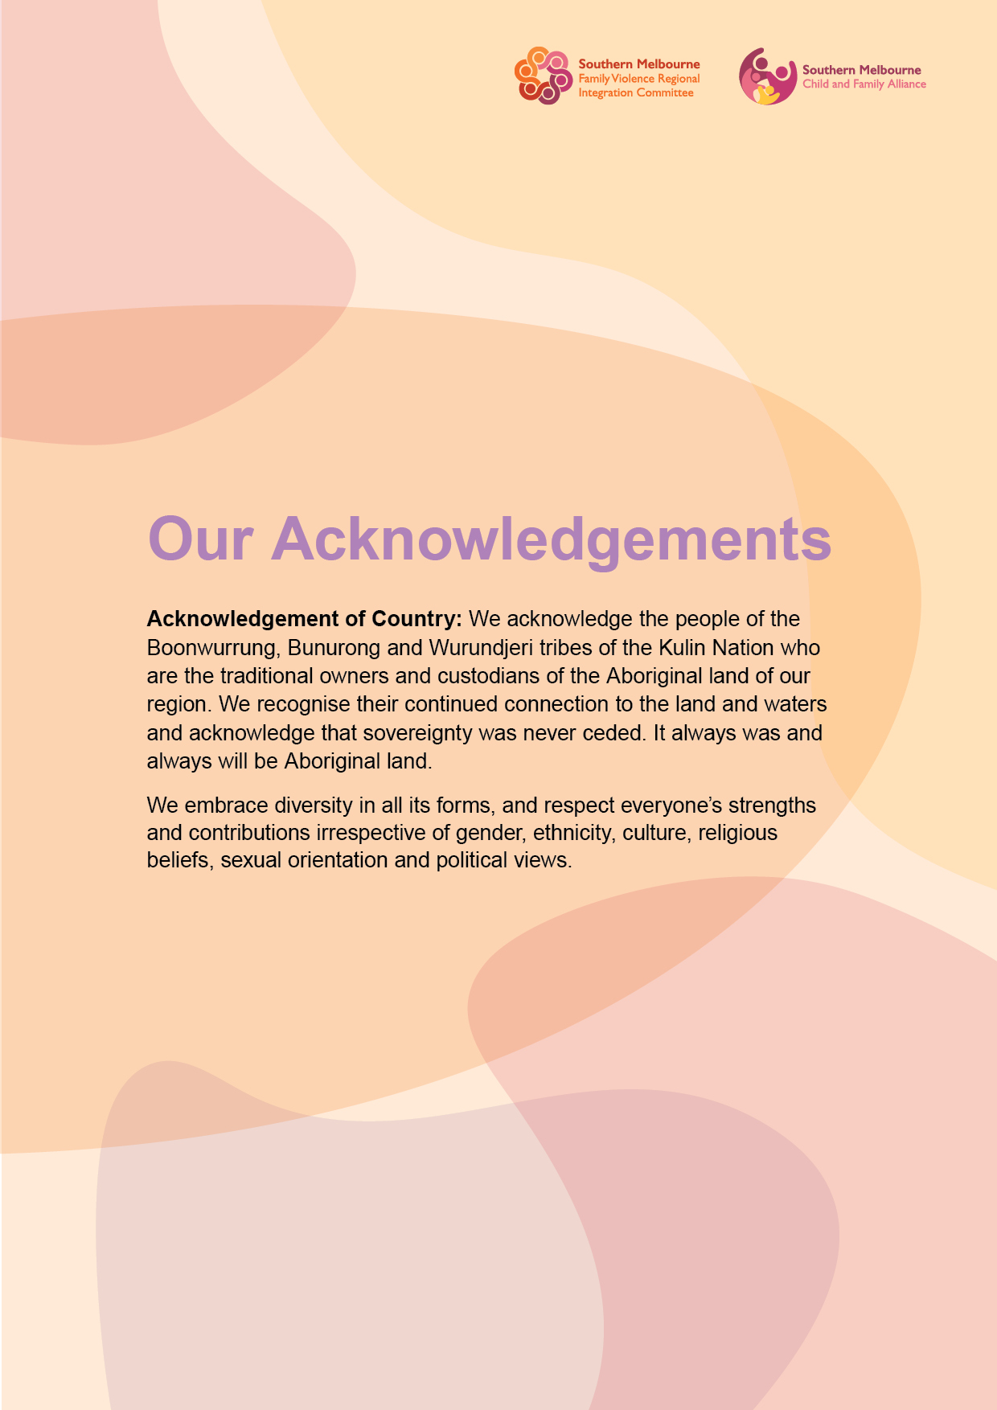

Morning Series Summary: Wellspring for Women
Guest Speaker: Dr. Maxwell Fraser
W:

For additional information:
________________________________________________________________________________________________

What is the HEAR model? developed by Emily Alison and Laurence Alison is a framework for building rapport with challenging clients, particularly those who are hostile or traumatised. It focuses on four key principles: Honesty (being transparent and authentic), Empathy (understanding the client's perspective without judgment), Autonomy (respecting the client's choices and avoiding coercion), and Reflecting (mirroring and summarizing to demonstrate understanding). This approach creates a safe environment for engagement by prioritizing rapport-building over immediate information-gathering or compliance.

Programs

Presentation Notes:

