School Holiday programs Autumn 2025

- City of Casey:
Bunjil Place
- 2 Patrick NE Drive, Narre Warren Victoria 3805
- What's On | Bunjil Place
- CCL_Brand-Launch_School-Holiday-Guide_Atumn2025_Digital.pdf
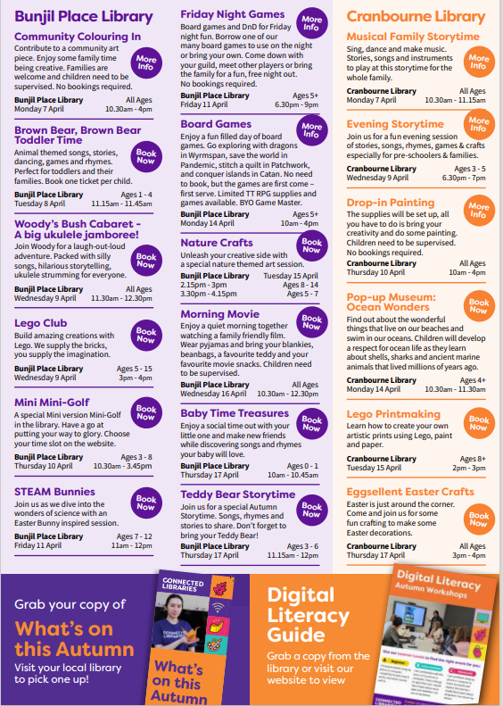

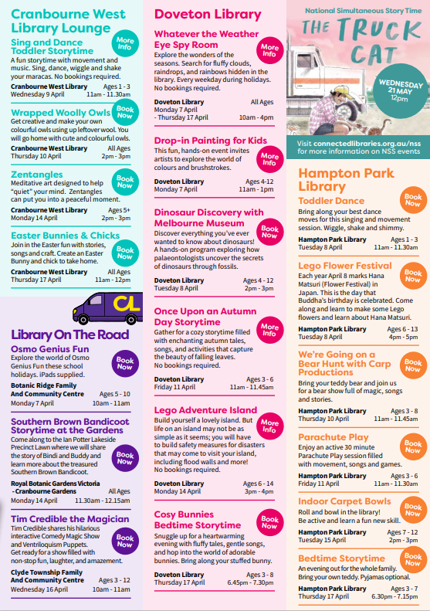

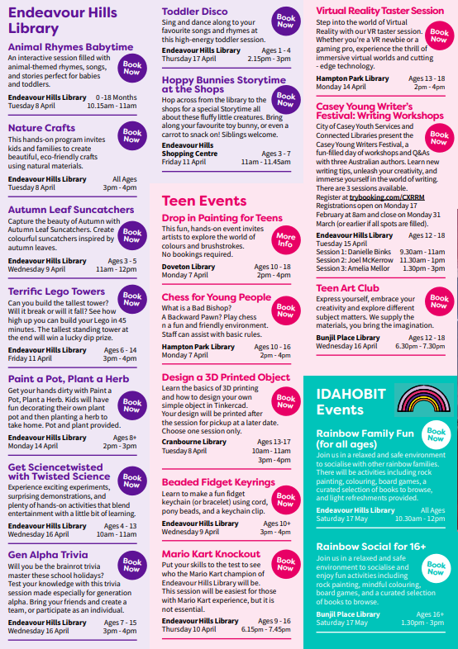

Teenage School Holiday Program | City of Casey
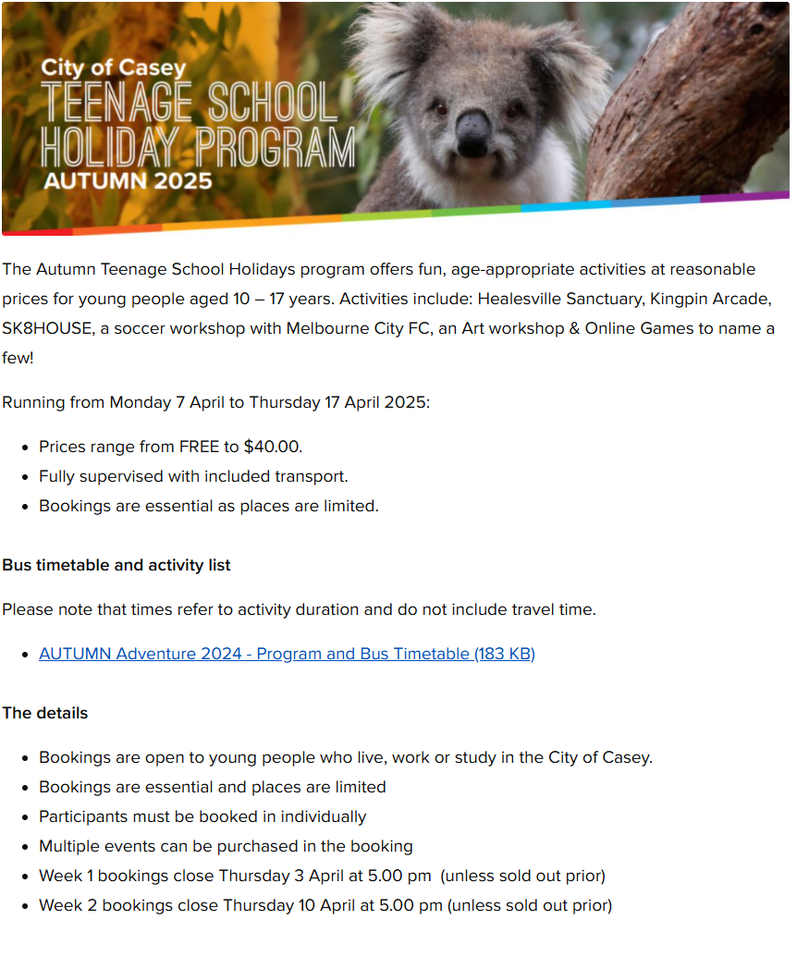

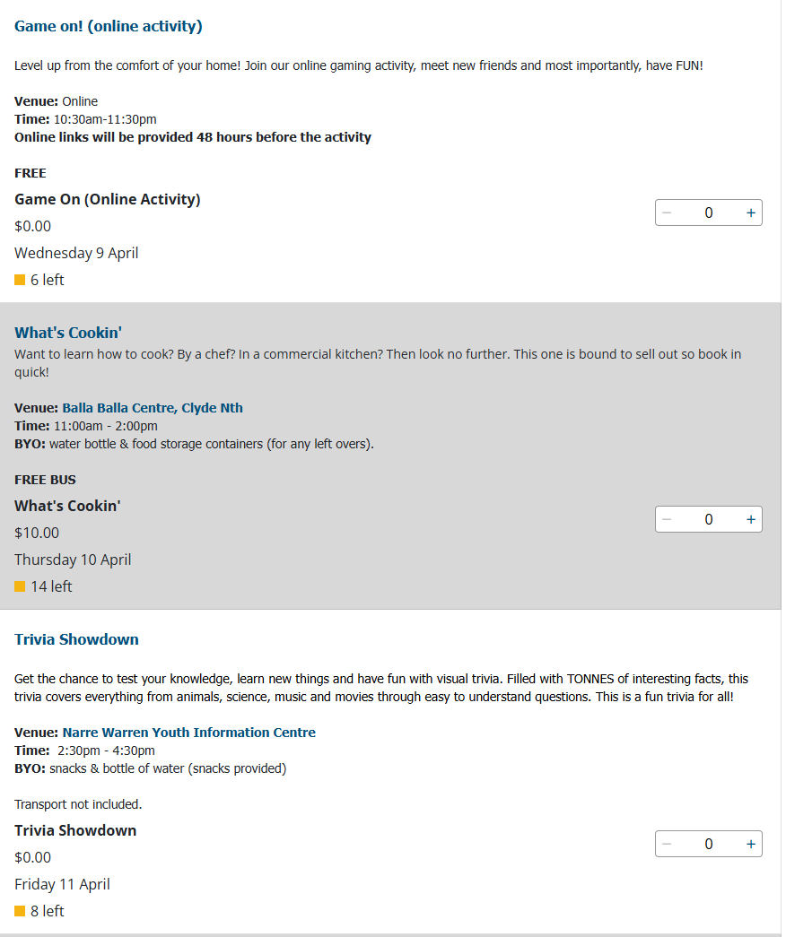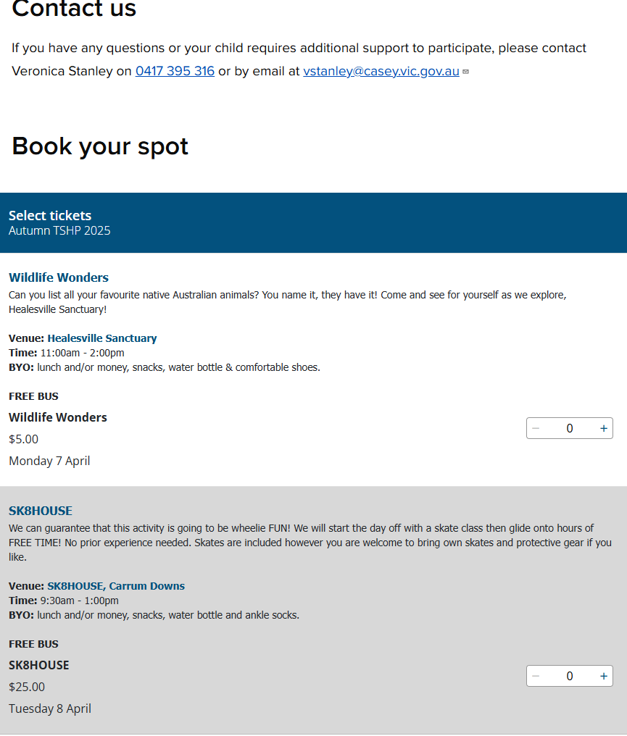

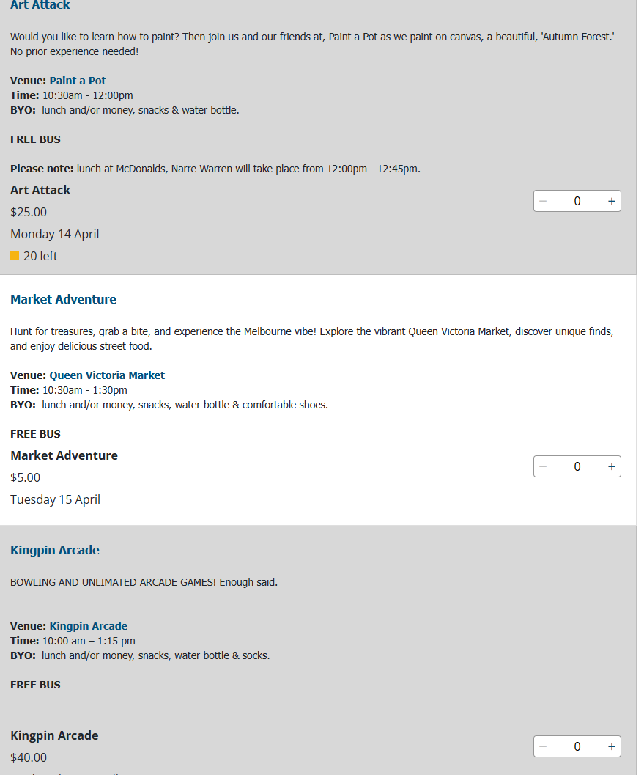

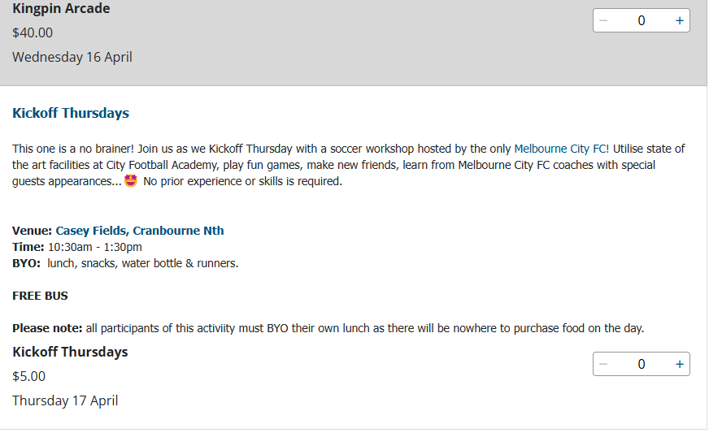

Merinda Park School Holiday program
School Holiday Program | MPLCC
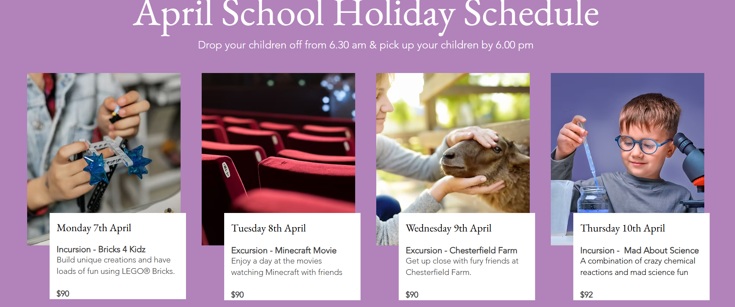
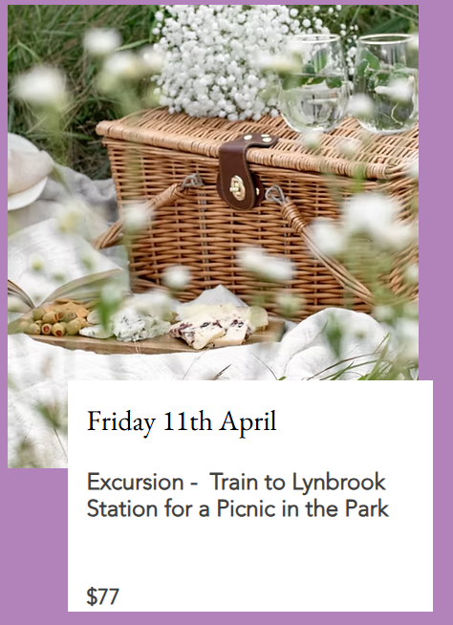
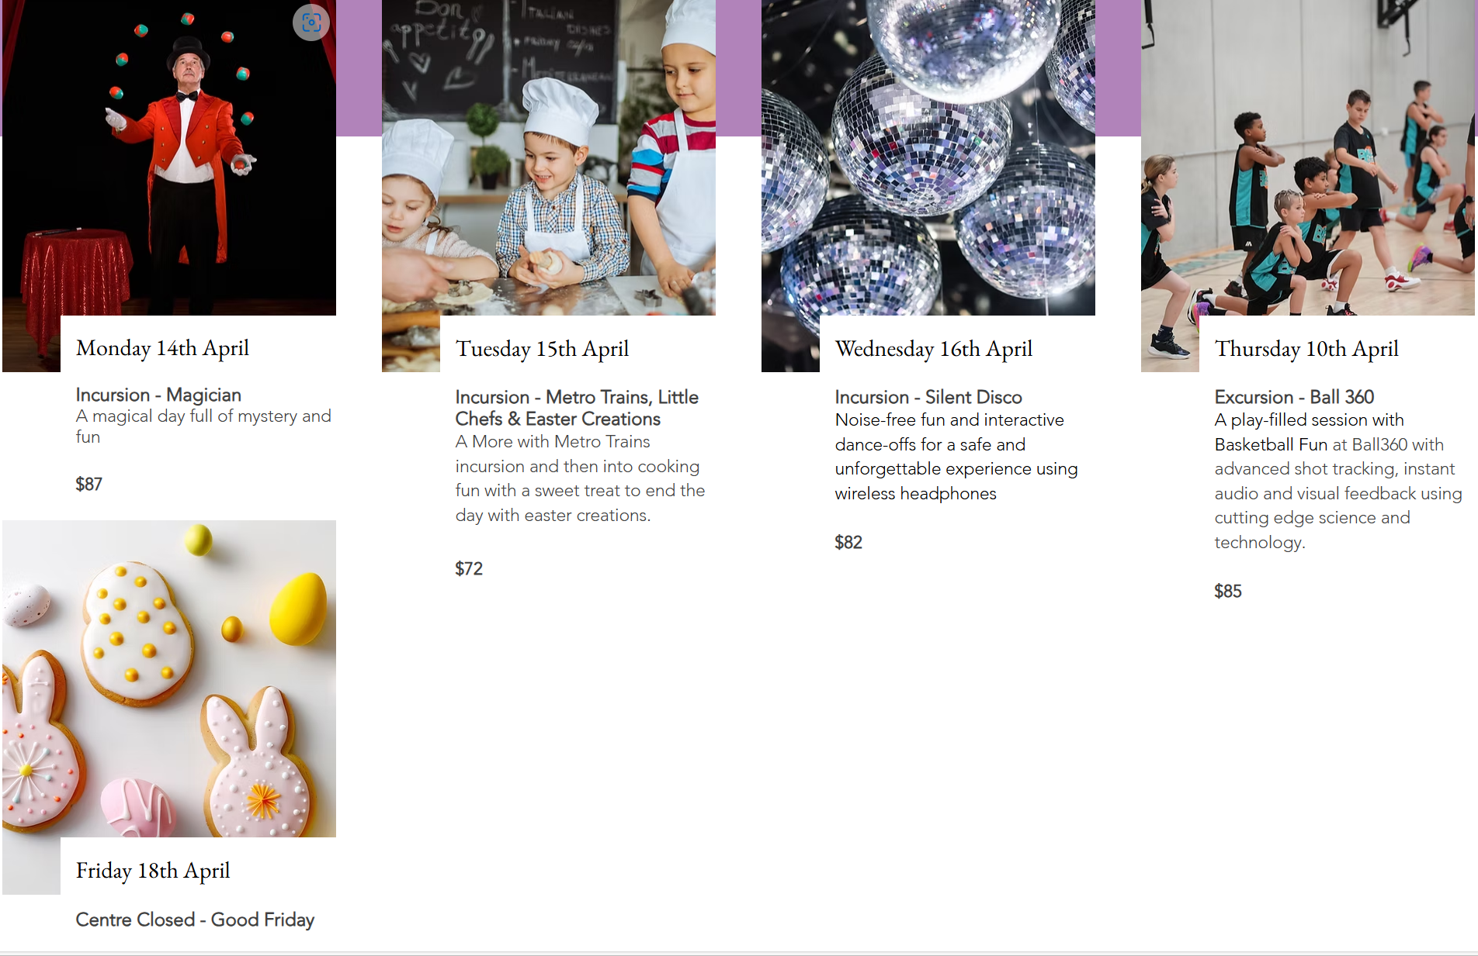
Hampton Park Community Centre
Vacation Care Programs
What's On
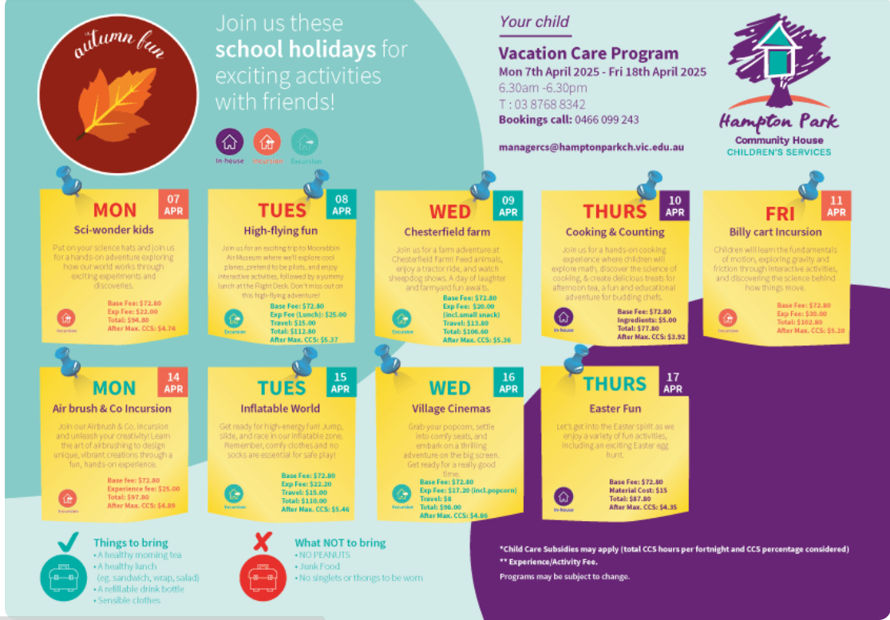

Fees.
As a Not for Profit Community Centre, we are proud to offer some of the lowest rates in the City of Casey and the Cardinia Shire.
​​​
All families eligible for CCS can claim their percentage for the entire daily fee,
eg. Standard day is $67, plus excursion. If you have a 90% CCS you will pay approximately $9.68. Totaling 69% =$23 out of pocket
​
Merinda Park is happy to assist with any enquiries.

​Enroll Now - call us on 5996 9056

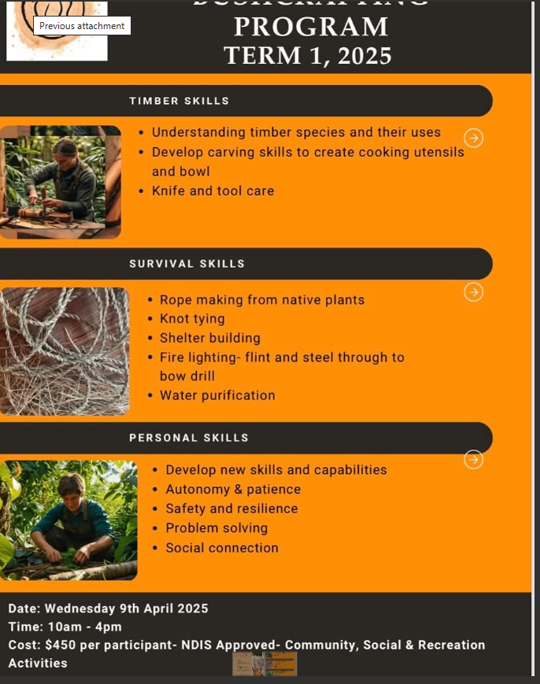
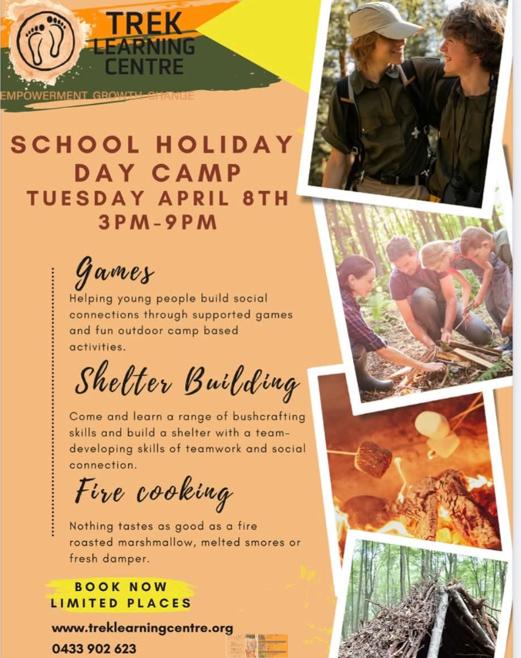
SCHOOL HOLIDAY PROGRAMS | Oakwood Horse Riding School Holiday program Cranbourne
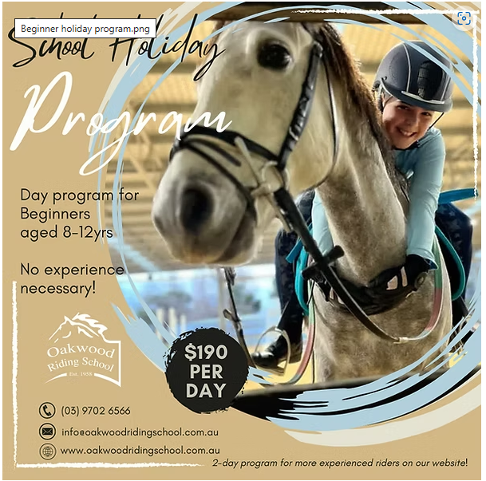

TRANQUIL PARK STABLES - Home Horse Riding School Holiday program Cranbourne
Bricks 4 Kidz
School Holiday Programs | Bricks 4 Kidz - Australia - Melbourne - North Casey
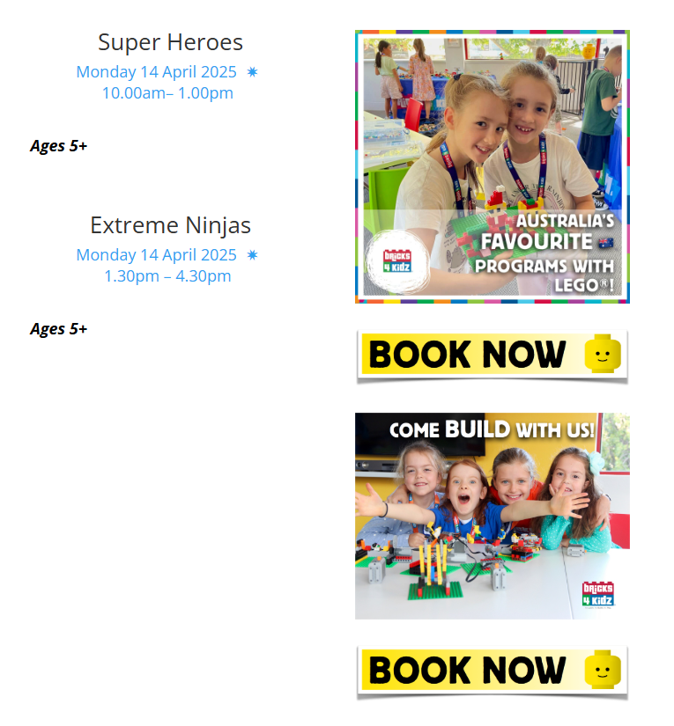

YMCA-See timetables for each area
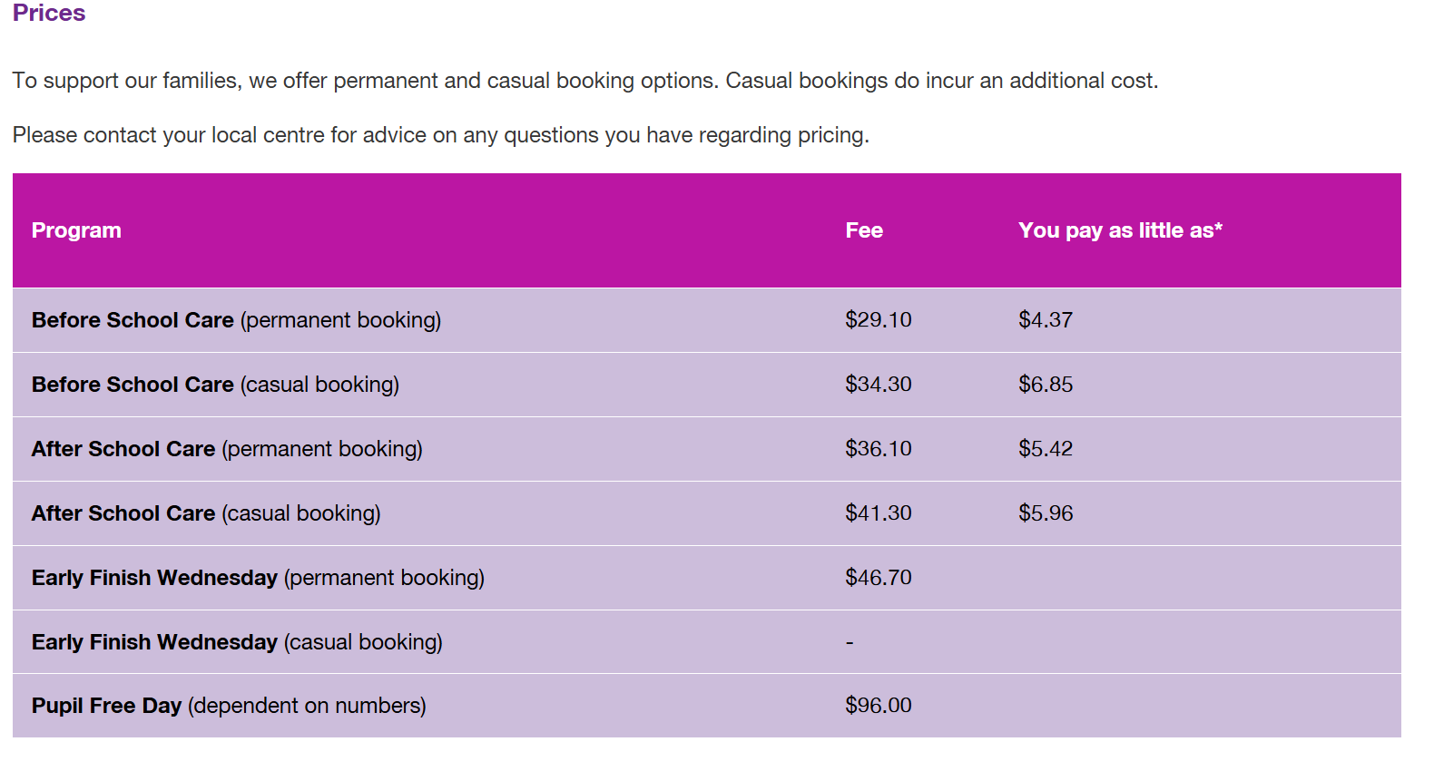
Cranbourne North Holiday Program and OSHC | YMCA Victoria | Y Victoria
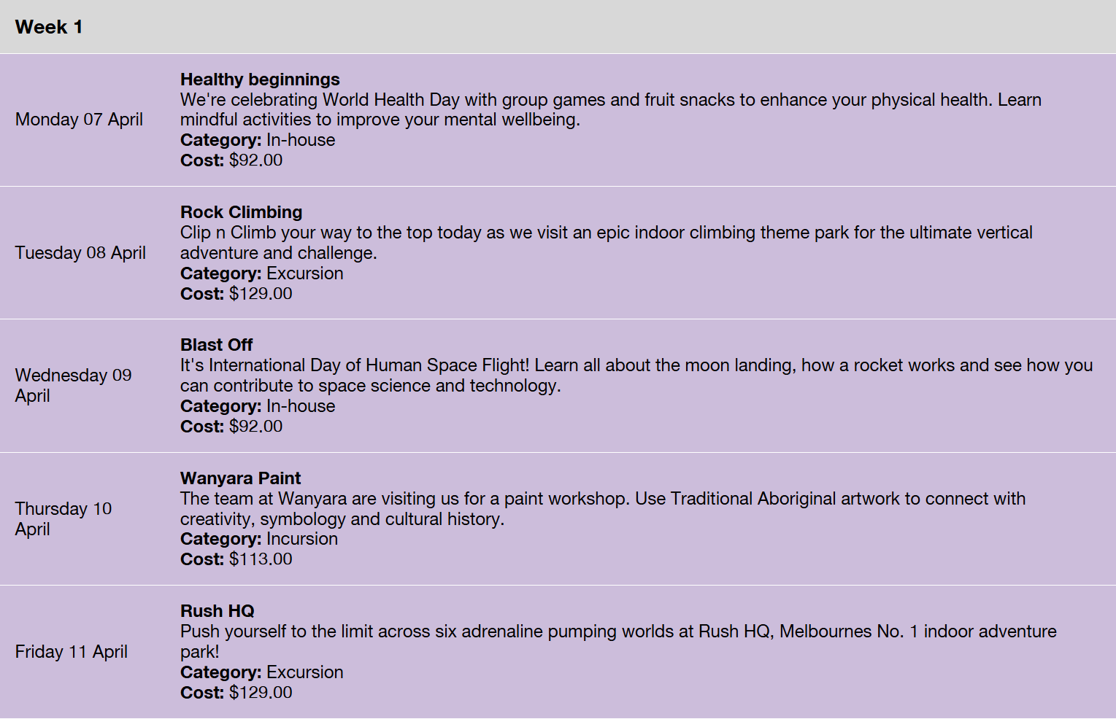
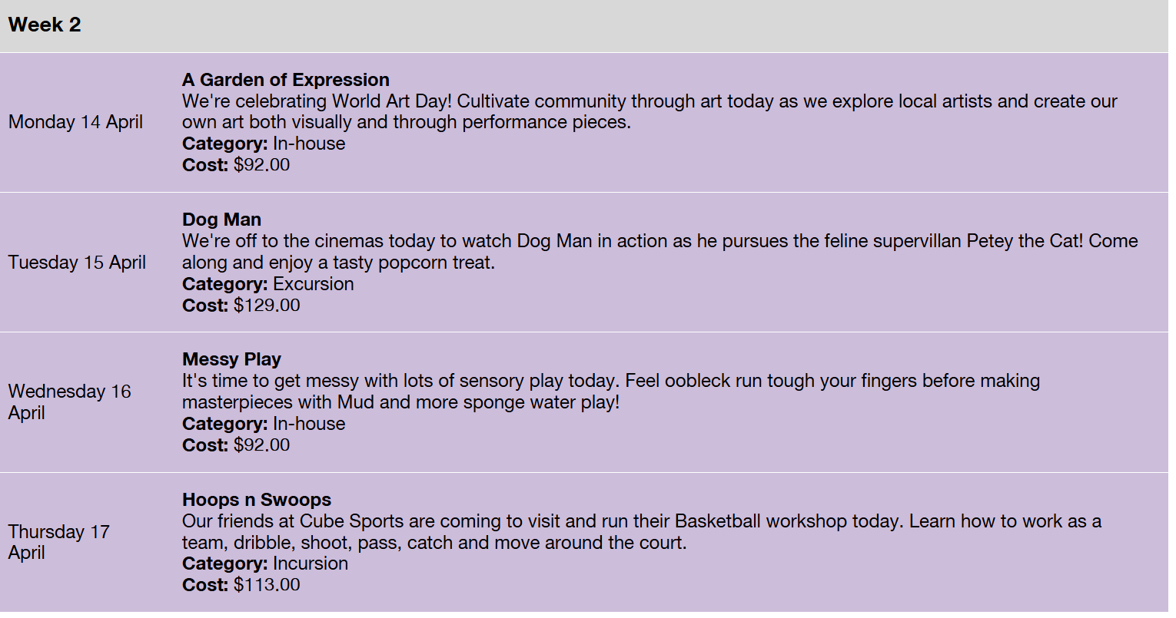

Cranbourne West Holiday Program and OSHC | YMCA Victoria | Y Victoria
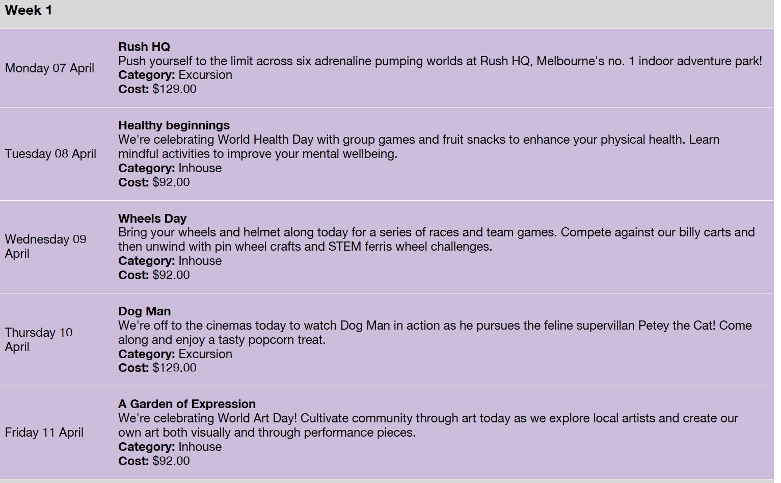
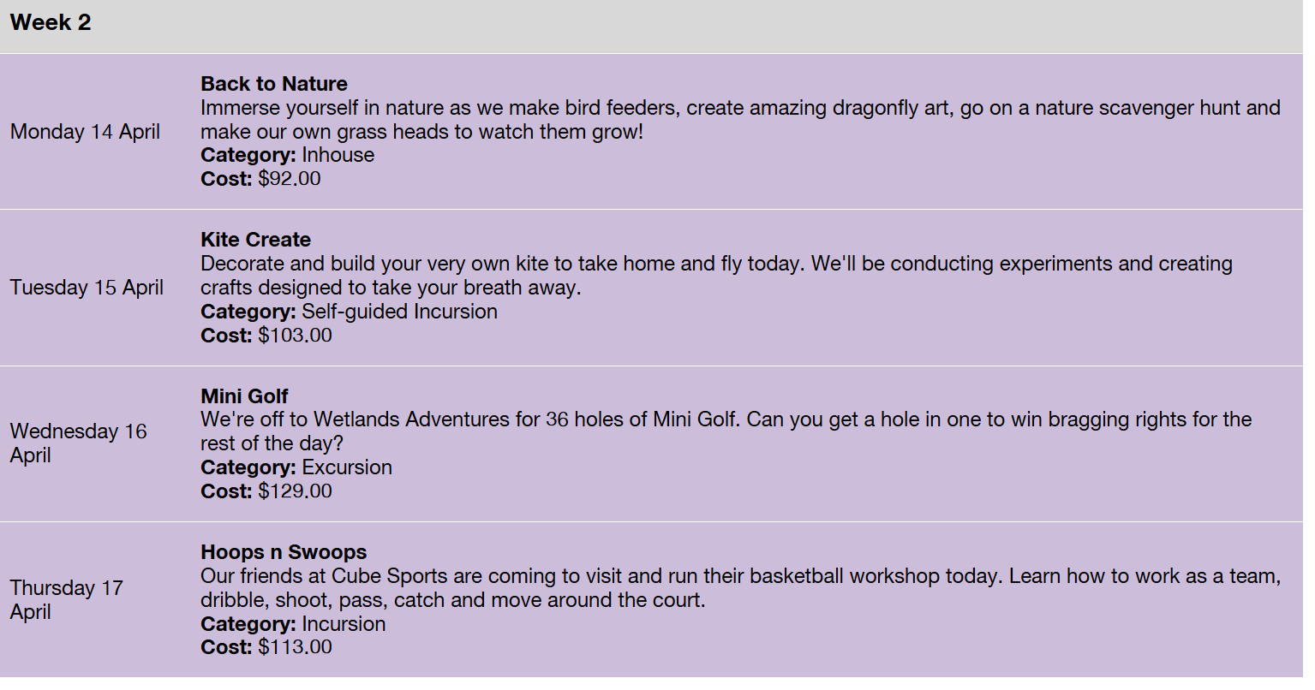
Clyde North Holiday Program and OSHC | YMCA Victoria | Y Victoria
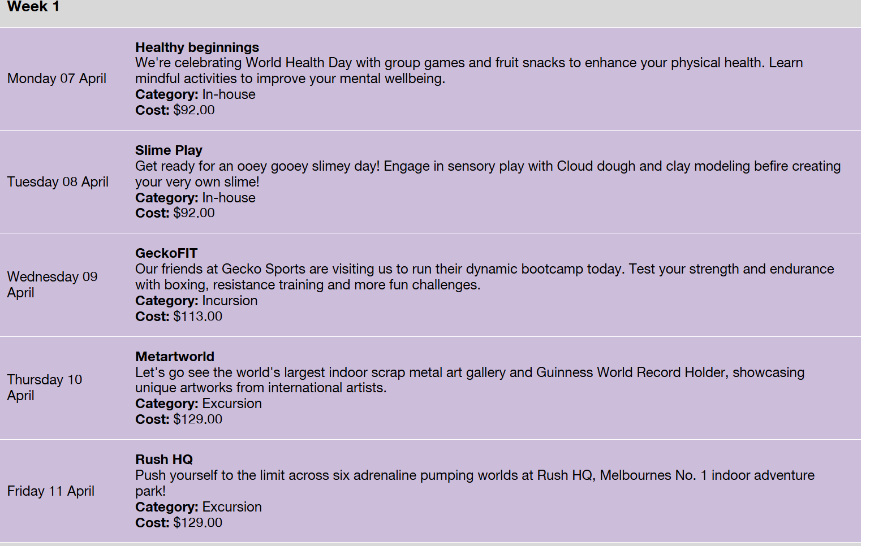
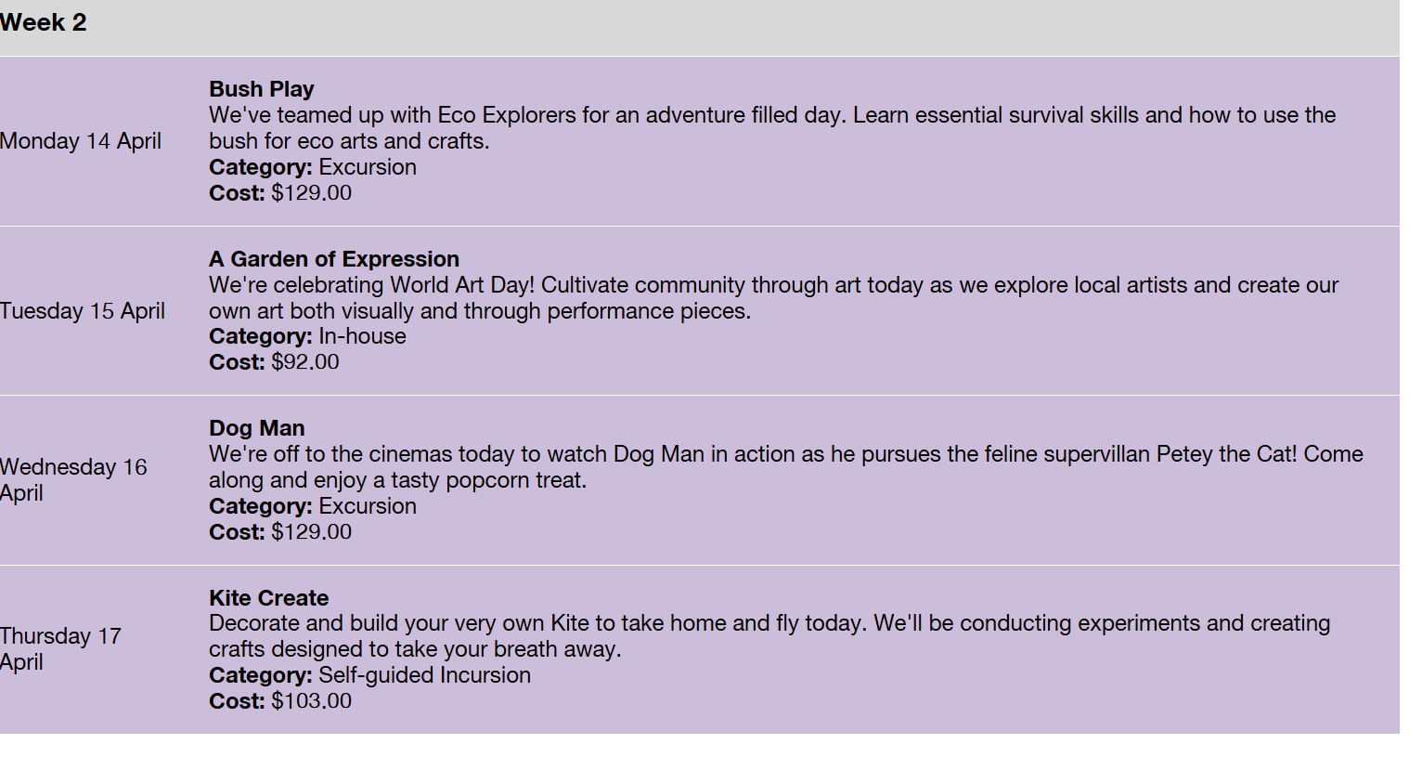
School Holiday Clinics | Casey Basketball
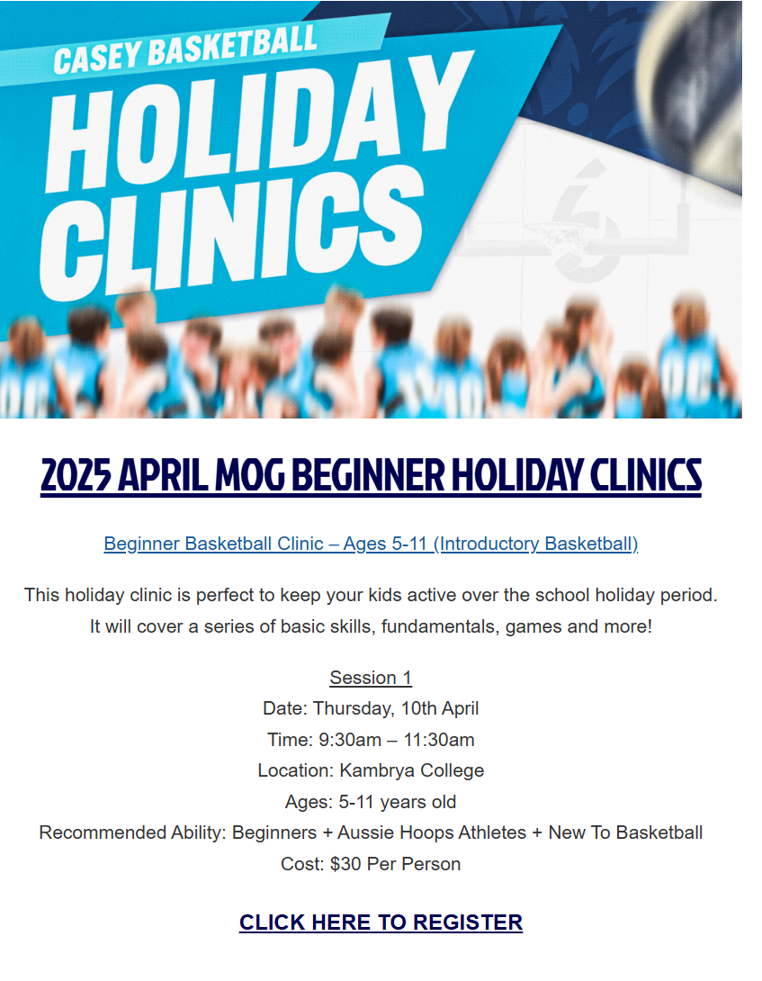

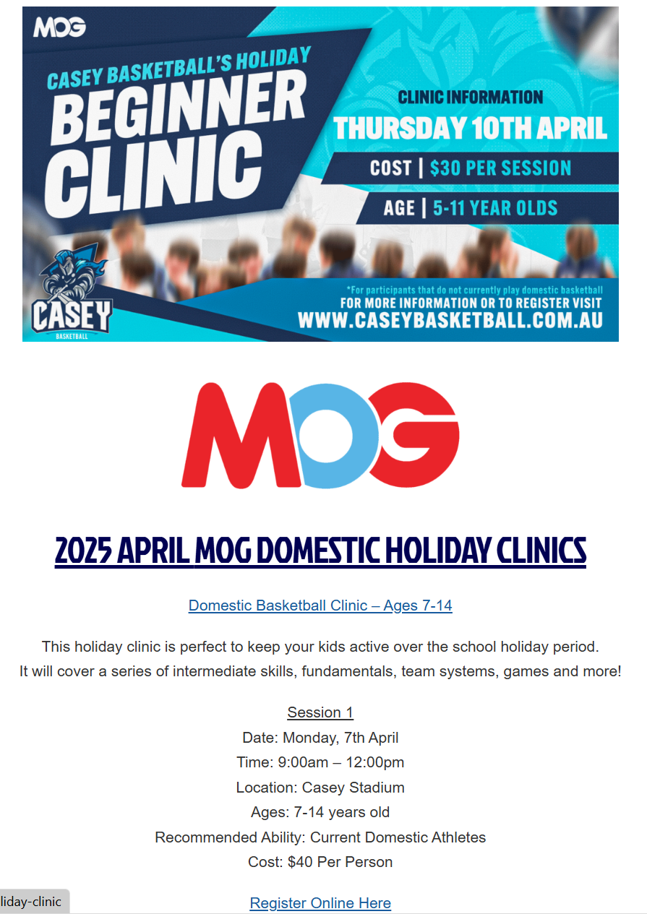
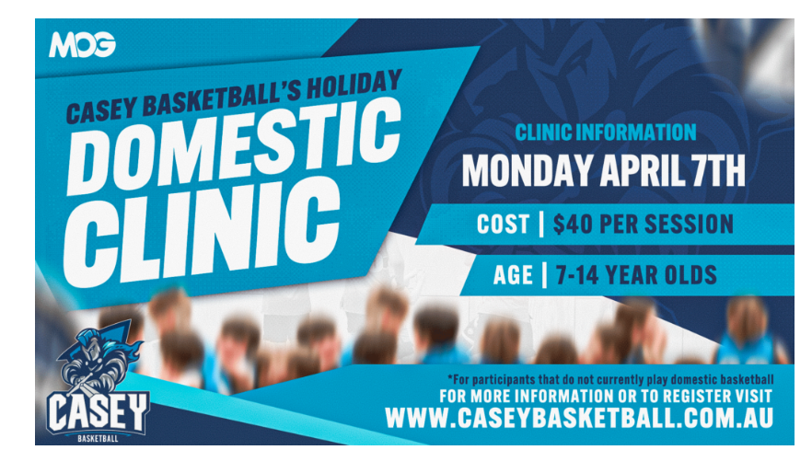

- CITY OF GREATER DANDENONG

- School Holiday Activities | Greater Dandenong Council
- Holiday Activities | Youth
- What's on in the Libraries | Greater Dandenong Libraries

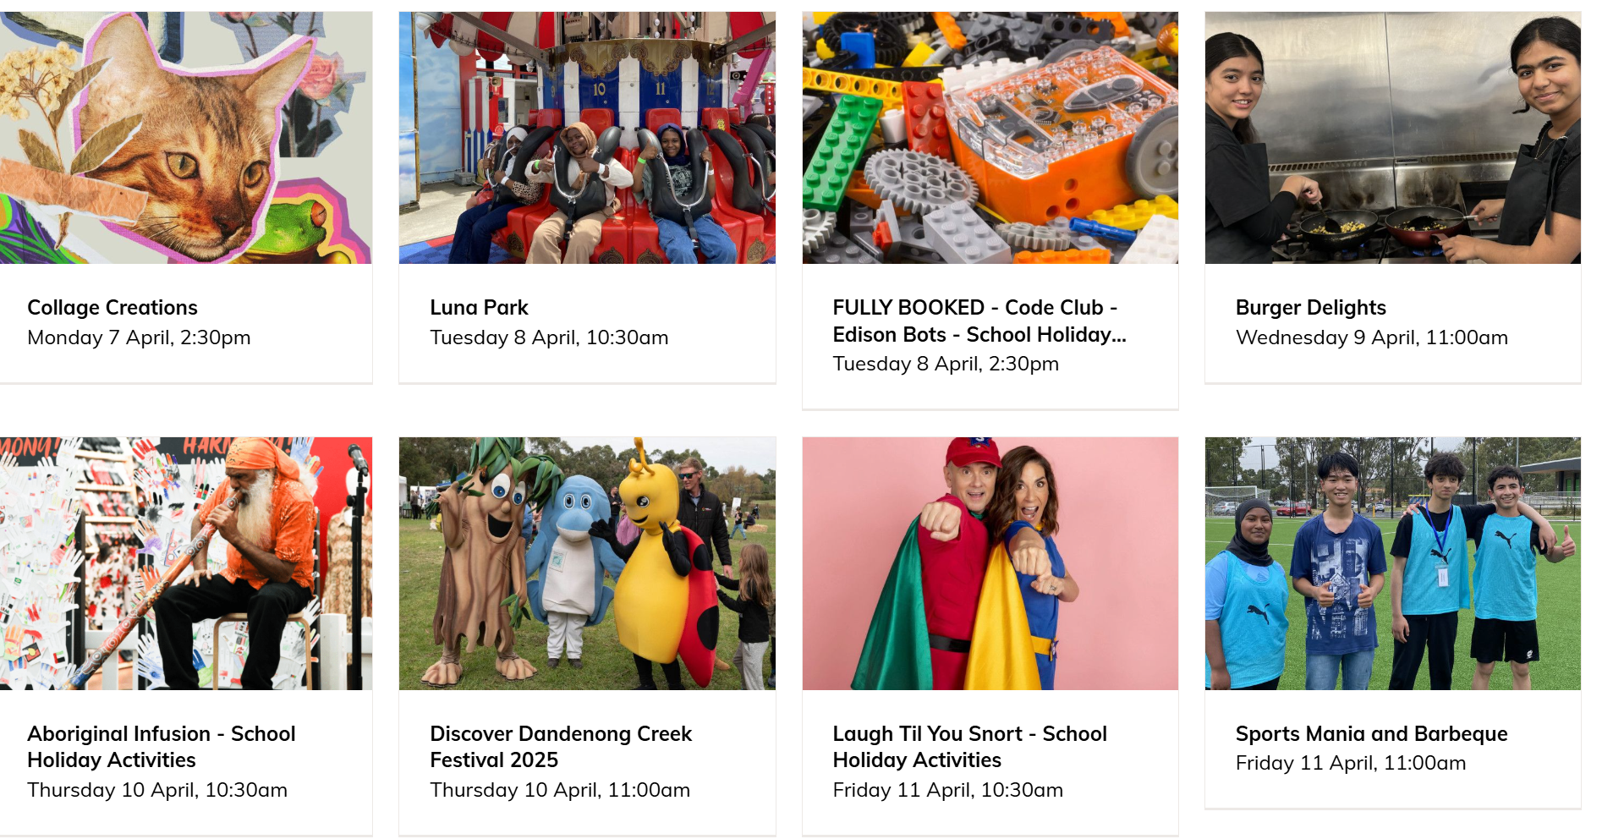

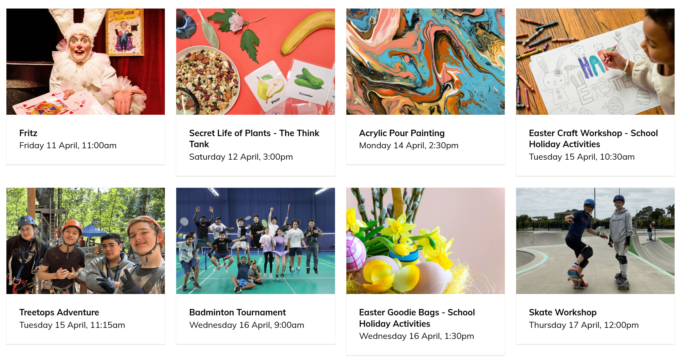

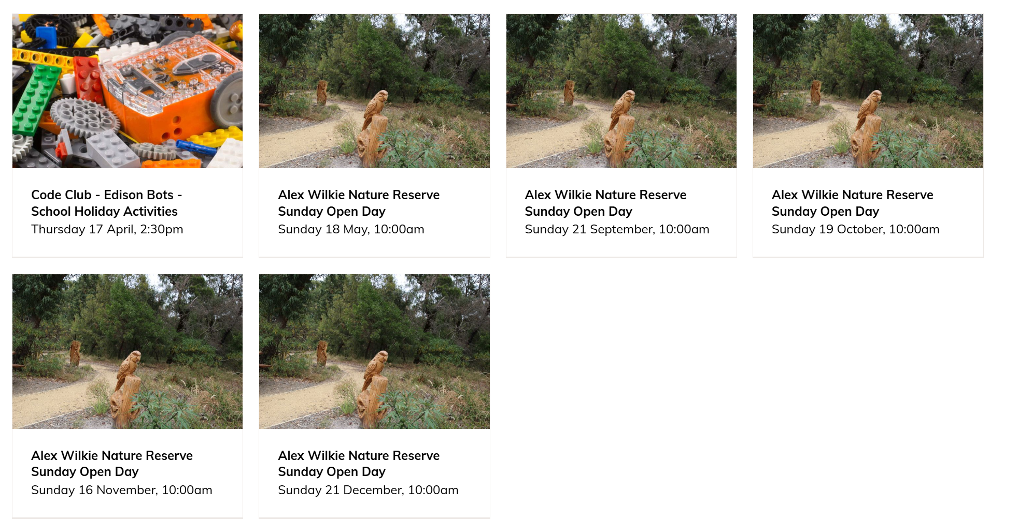
Springvale Indoor sports

School Holidays – Springvale Indoor Sports
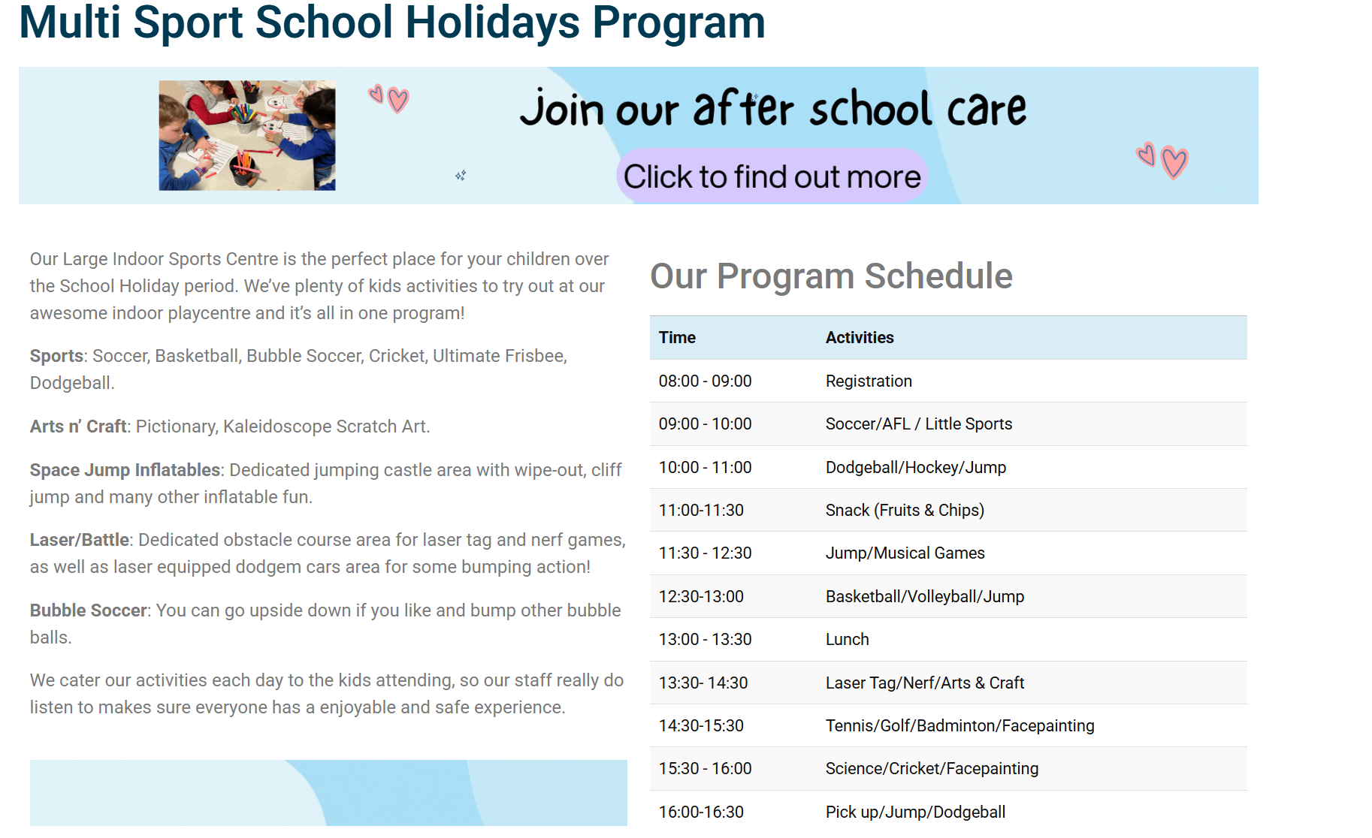

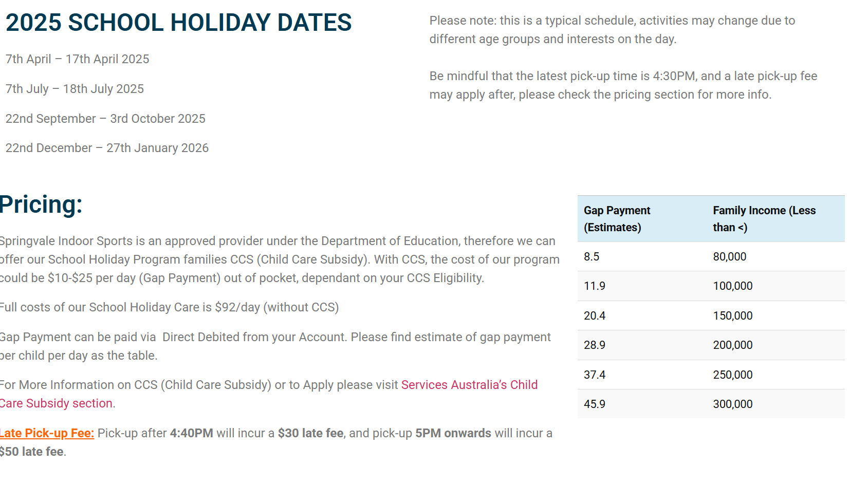

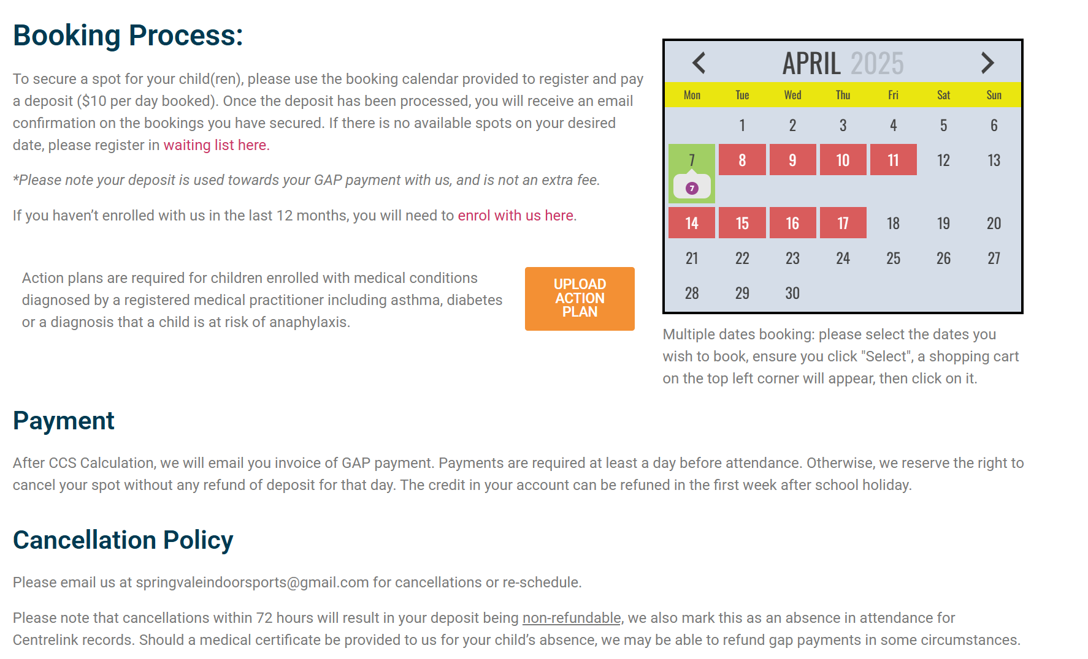

- CARDINIA SHIRE:

Teenage School Holiday Program for Summer 2025 - Cardinia Shire Council

- Our Teenage School Holiday program is open to young people aged 12 to 17 years.
- Activities are held across Cardinia Shire during the school holidays. Most activities are low cost or free.
- Transport to and from some activities - from selected locations may be available. Please contact My Place Youth Centre for further information.
- Bookings for all activities are essential. Please book using the online form.

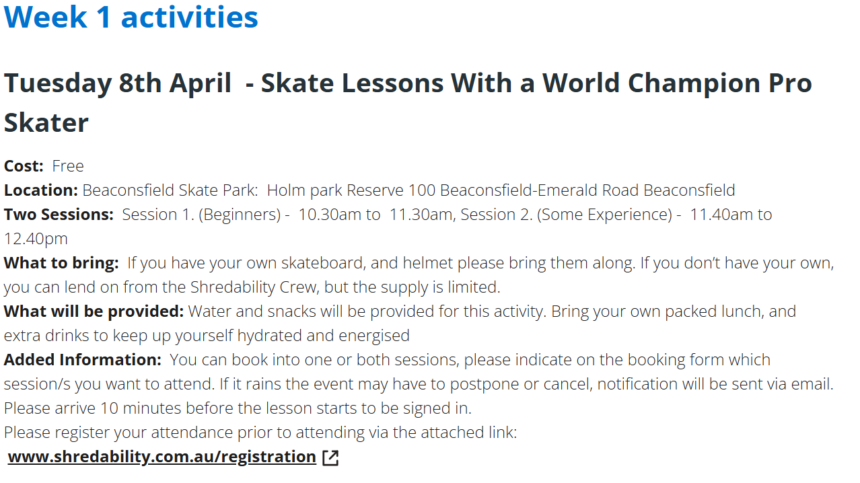
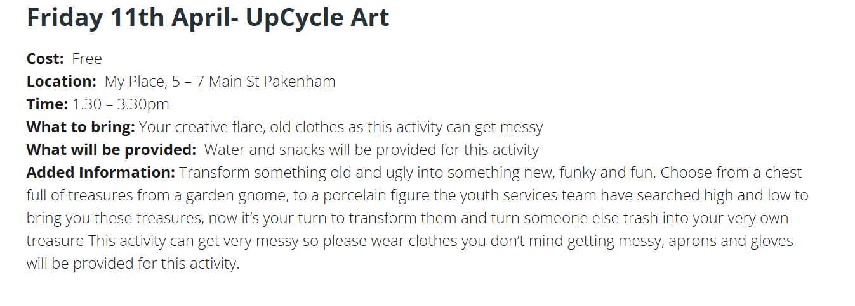
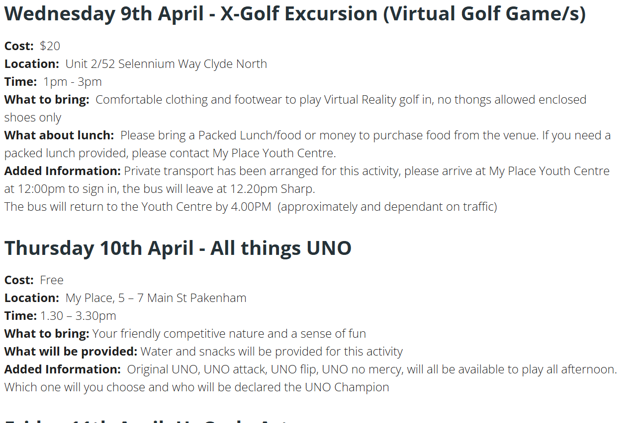

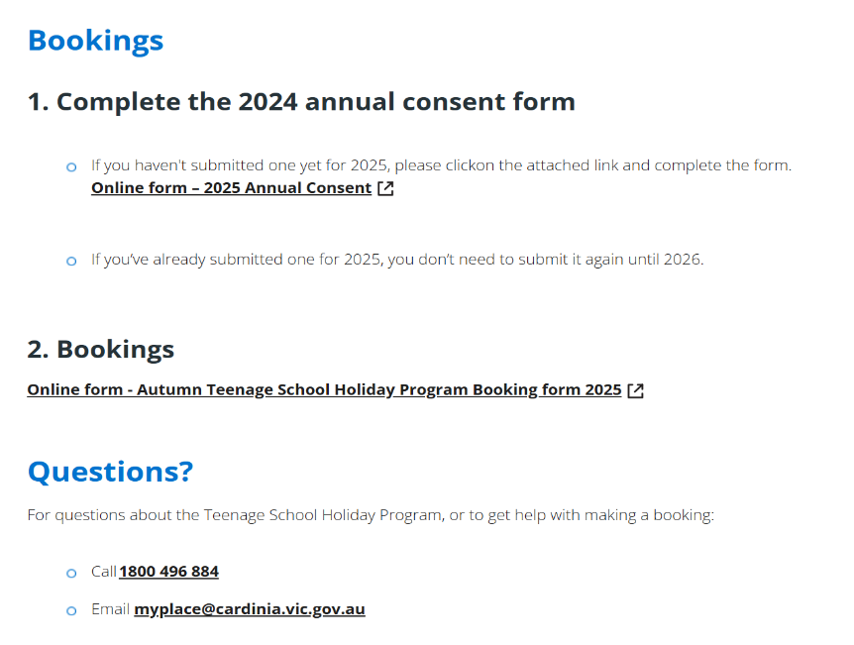
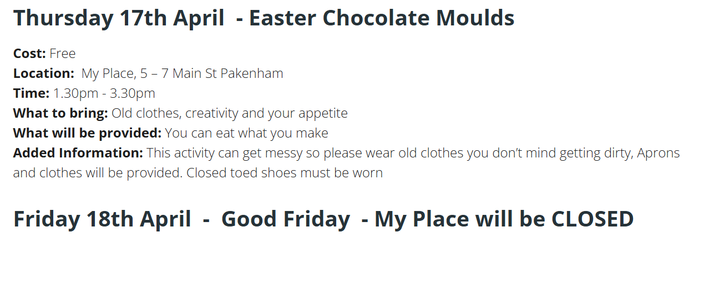
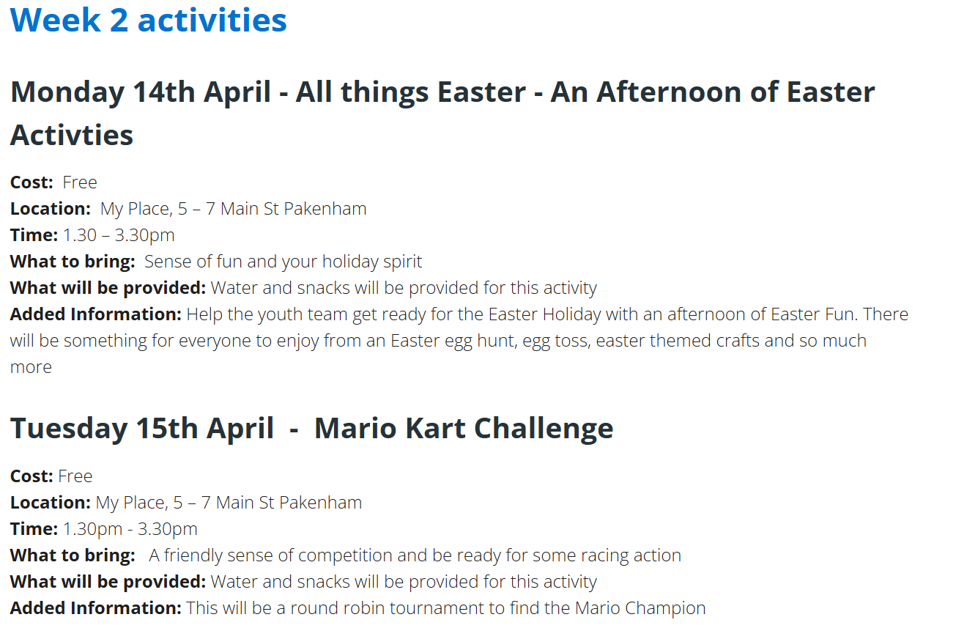

Holiday Program - Cooking 4 Kids
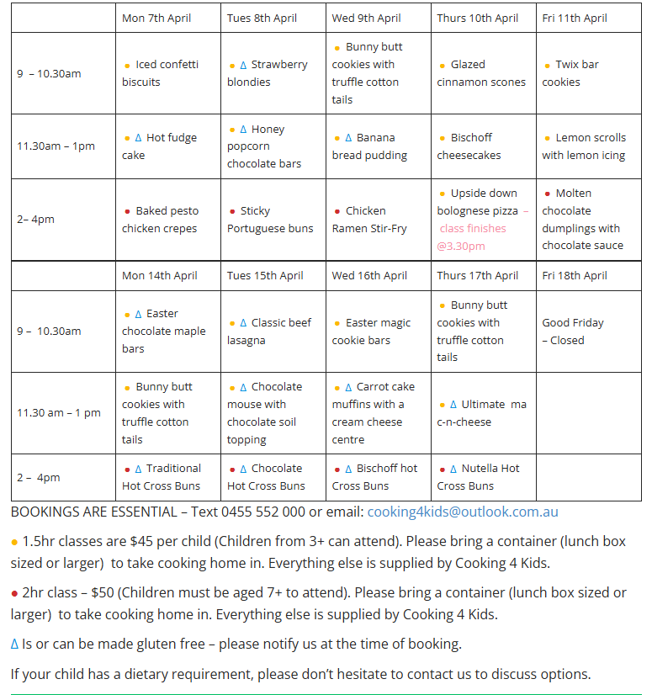

- ABORIGINAL SPECIFIC:
(1) Facebook
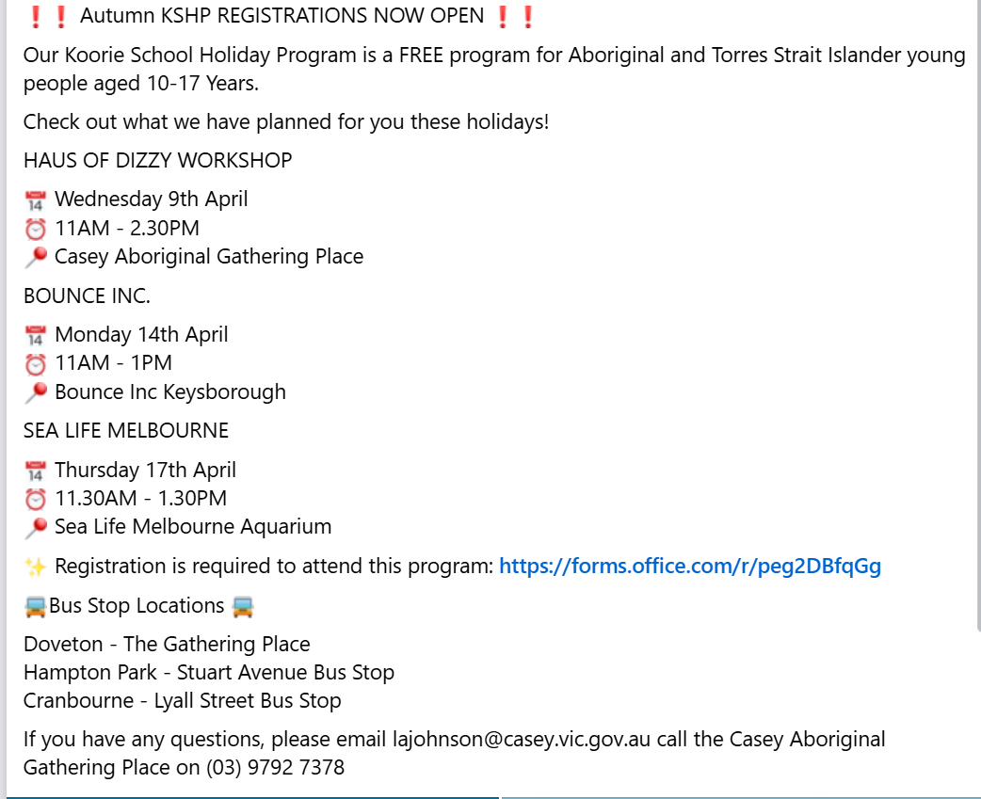

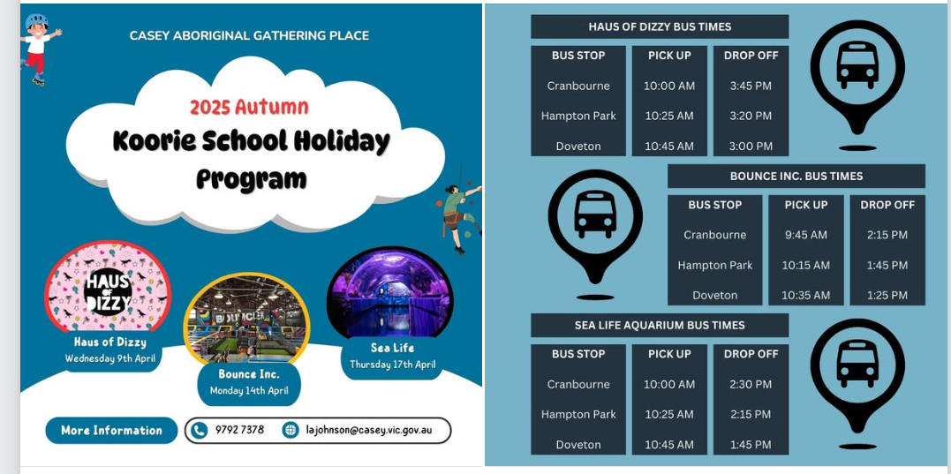

- DISABILITY SPECIFIC:
We Rock the Spectrum Kids Gym (Clyde North):
- Mental Health
- Satellite Foundation:
- Whats On | Satellite Foundation
- Satellite’s programs are for children and young people ages 8-25 years, who have a family member living with mental health challenges. This may also include young people in families experiencing challenges with substance use, family conflict or violence, complex trauma, or other adverse life circumstances. Our programs are designed to be fun, creative and engaging, with plenty of space for talking, getting support, connecting with others, and creating new friendships.

