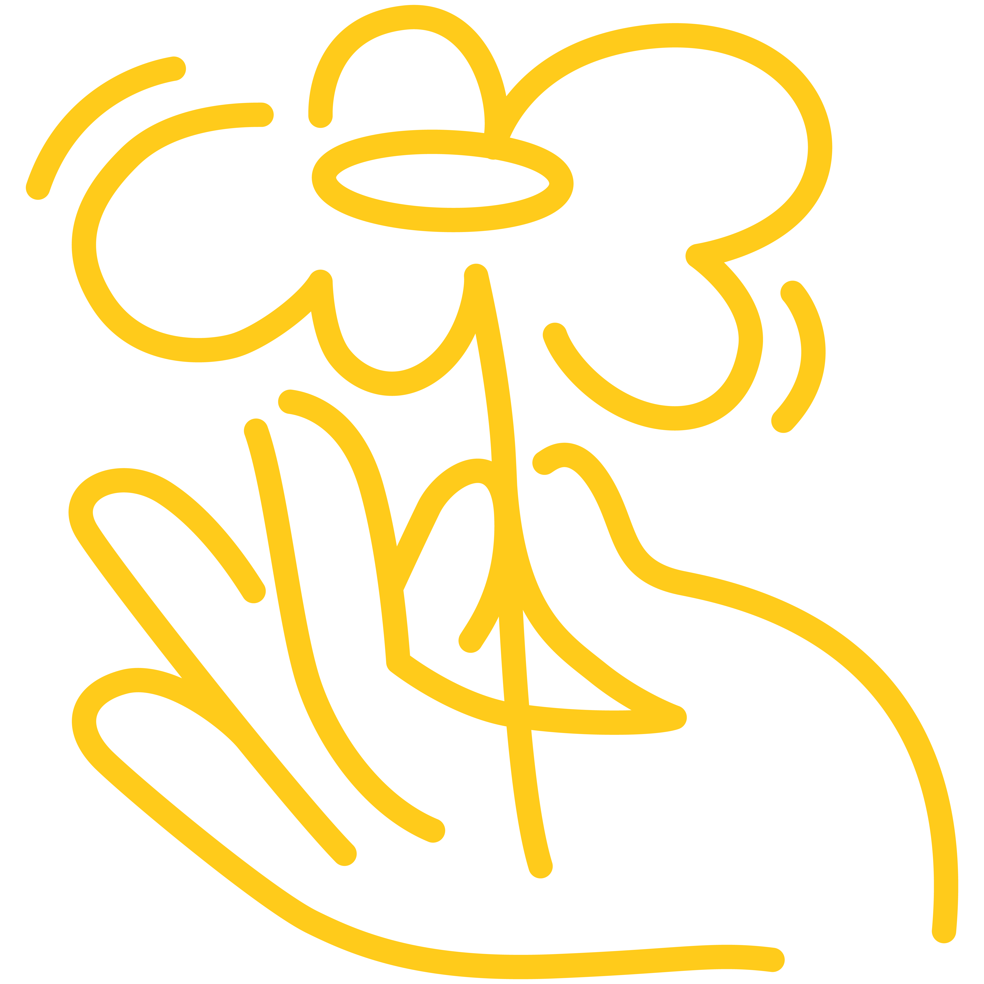
Making
changes
for new beginnings
A therapeutic support group for women
Have you felt scared, intimidated, threatened or unsafe in your relationship with your partner?

Did you have control of your finances?

Has your partner blamed you for their abusive behaviour?
Making Changes for New Beginnings is a 8 week support group for women who have experienced family violence.
The group aims to help you identify the effects of abusive relationships and create new beginnings for yourself.
Topics covered include:
- Cycle of violence
- Difference between anger and violence
- Healthy and unhealthy relationships
- Safety planning
- Parenting after family violence

Cost
Free
Date
Monday 4th May 2026- Monday 22nd June 2026 (no group on 8th June- King’s Birthday).
Time
10:30am-12:30pm
Venue
Narre Warren
Light refreshments will be provided.
Get in touch
For more information or to book, contact Aslin or Mary-Anne on
8792 8999

Register
https://forms.office.com/r/HSQwssy27K


