
Southern Melbourne Child & Family Alliance

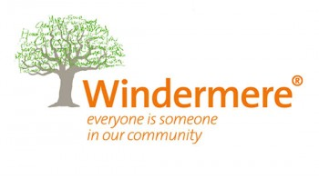

Disability Secondary Consultation
Family Services Specialist Disability Practitioner

The Family Services Specialist Disability Practitioner (FSSDP) is a free consultation service to the Southern Melbourne Child and Family Alliance to build the capacity and support practitioners in responding to children and families with disability.

The purpose of these roles is to:
- Provide secondary consults to the broader Family Services service system.
- General advice on navigating or accessing NDIS.
- Support families to access and navigate NDIS.
- Finding local disability or NDIS providers.
- Joint home visits where appropriate.
- Case discussion and advice to supporting case planning.
- Parenting and behavioural support related to disability issues.
- Support with flexible funding related to specific disability needs [eligibility criteria applies].

How can I access a consultation or support?

VACCA
For Aboriginal or Torres Strait Islander Families:
- Contact: Sarah Barnes
- Email: sbarnes@vacca.org
- Phone: 0460 312 028

WINDERMERE
- Contact: Tracey McQueen
- Email: tracey.mcqueen@windermere.org.au
- Phone: 0418 531 128

