Clutter Image Rating Scale (CIRS)
The purpose of this tool is to gauge the impact of hoarding on the person with the hoarding behaviour.

Clutter Image Rating Scale: Part 1 of 3 – Kitchen
Please select the photo below that most accurately reflects the amount of clutter in your room.
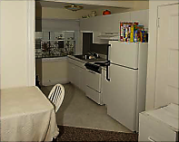 | 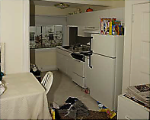 | 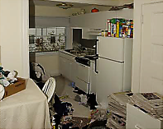
1 | 2 | 3
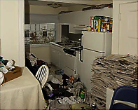 | 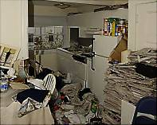 | 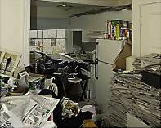
4 | 5 | 6
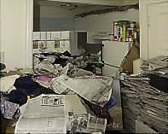 | 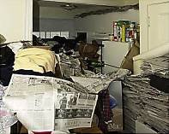 | 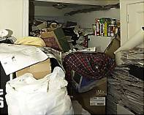
7 | 8 | 9

Clutter Image Rating Scale: Part 2 of 3 – Bedroom
Please select the photo below that most accurately reflects the amount of clutter in your room.
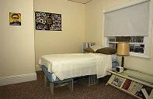 | 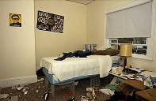 | 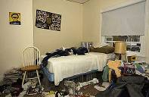
1 | 2 | 3
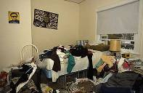 | 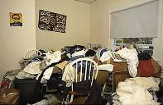 | 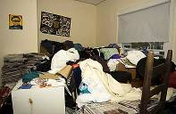
4 | 5 | 6
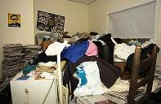 | 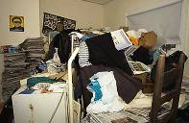 | 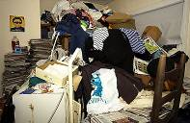
7 | 8 | 9

Clutter Image Rating Scale: Part 3 of 3 – Living room
Please select the photo below that most accurately reflects the amount of clutter in your room.
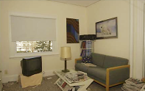 | 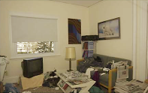 | 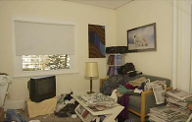
1 | 2 | 3
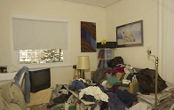 | 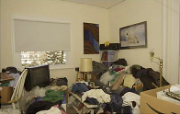 | 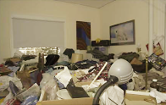
4 | 5 | 6
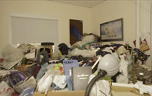 | 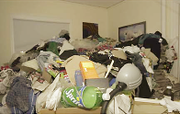 | 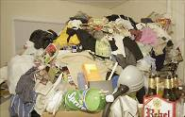
7 | 8 | 9

Source: Frost RO, Steketee G 2006a, Compulsive Hoarding and Acquiring: Therapist Guide. New York. Oxford University Press. The Clutter Image Rating (CIR) Tool, p. 188. Used with permission of Oxford University Press, USA.

